Step 1: Stationary Audio Loading
In the first step, we built a robust "Audio Factory" function. Here is exactly what it does:
- Consistency: It guarantees that every signal you work with is exactly the same length (1 second / 8000 samples). This is crucial for the math in later steps (Beamforming) to work without errors.
- Stationarity: By taking a random 1-second slice from the file, we capture a snapshot of the vessel's engine noise. This assumes the engine sound doesn't change drastically within that single second (which is true for ships). If the file is too short, we loop it to fill the gap.
- Normalization: We centered the signal (removed DC offset) and scaled the maximum amplitude to 1.0. This gives us a standardized "clean" signal, which makes calculating the noise level in the next step much more accurate.
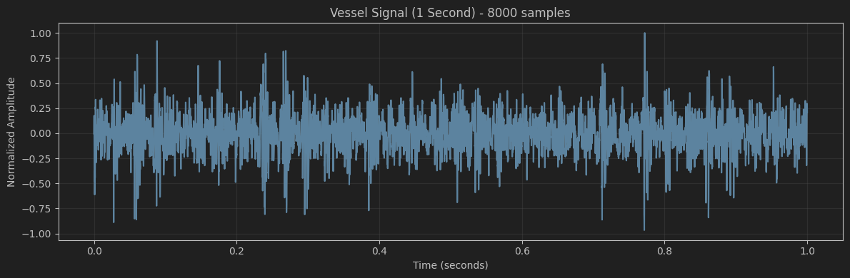
(we also have the signal audio)
Explanation of Step 2: Adding Noise (SNR Control)
What we did:
We injected "White Gaussian Noise" into the clean signal. The amount of noise was calculated mathematically to ensure a Signal-to-Noise Ratio (SNR) of 10dB.
SNR (Signal-to-Noise Ratio) compares the power of the signal to the power of the noise.
Formula: $SNR_{dB} =10⋅\log_{10}\left(\frac{P_{signal}}{P_{noise}}\right)$
Why is it hard to see?
An SNR of 10dB means the signal is 10 times more powerful than the noise
($\frac{P_{signal}}{P_{noise}} = 10$).
In terms of amplitude (height of the wave), the signal is about 3.16 times larger than the noise.
- Because the signal is much stronger, it dominates the shape. The noise just looks like a small "fuzz" or "jitter" on top of the original wave.
- When you plot 8000 points at once, this fine detail gets lost, and the lines just look slightly thicker.
How to Observe the Difference
To see the noise clearly, we need to zoom in on a very small fraction of a second. We can also plot the noise by itself (the difference between the two signals).
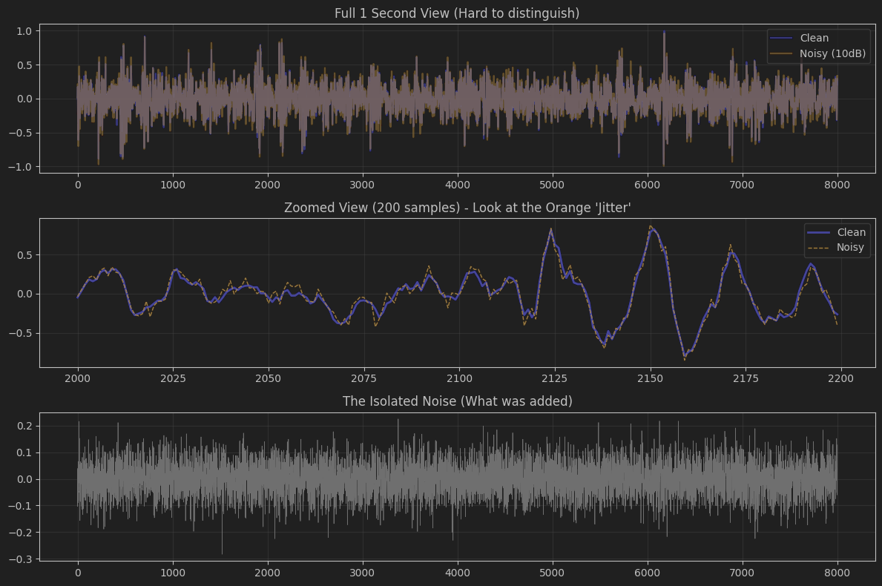

Step 3: Physics Engine (Sensor Array Simulation)
1. Attenuation (The "Radius" Effect)
Sound loses energy as it spreads out. We modeled Spherical Spreading Loss, which means the amplitude drops as the distance ($r$) increases:
$$Amplitude_{received}∝ \frac{Amplitude_{source}}{r}$$
- A vessel at 100 meters will be 10x louder than the same vessel at 1000 meters.
- In the code: attenuated_signal = source_signal / radius_m
2. Time Delay (The "Angle" Effect)
This is the most critical part for beamforming. Because sound travels at a finite speed, it reaches different sensors at different times depending on the arrival angle ($θ$).
- If $θ= 0^{∘}$ (Broadside): The wave hits all sensors simultaneously. There is no delay difference.
- If $θ= {90}^{∘}$ (Endfire): The wave travels along the line of sensors. It hits Sensor 0 first, then Sensor 1, etc.
- The Formula: The time delay $τ_{n}$ for the n-th sensor is:
$$τ_{n}=\frac{n⋅d⋅sin⁡(θ)}{c}$$
  - d: Spacing between sensors ($\frac{λ}{2}$).
  - c: Speed of sound.
3. The "Phase Shift" Trick
Instead of trying to shift the arrays in the time domain (which is hard to do for fractional samples, like "delay by 3.4 samples"), we used the Frequency Domain.
- Fourier Transform: We converted the signal to the frequency domain (FFT).
- Phase Shift Property: A time delay of $\tau$ is mathematically identical to multiplying the signal's phase by $e^{-j2πfτ}$.
- Inverse Fourier Transform: We multiplied the signal by this phase factor and then converted it back to time (IFFT). This results in a perfectly delayed signal with sub-sample accuracy.
The Result: A matrix of size [100, 8000].
- Rows (0-99): The individual sensors.
- Columns (0-7999): The time samples.
- If you look at this matrix, the signal in row 99 is slightly shifted to the right compared to row 0 (if the angle is not zero).
If your angle is positive (e.g., 45°), the Orange line should appear to the right of the Blue line.
If your angle is negative (e.g., -45°), the Orange line should be to the left.
If angle is 0°, they should lie perfectly on top of each other.
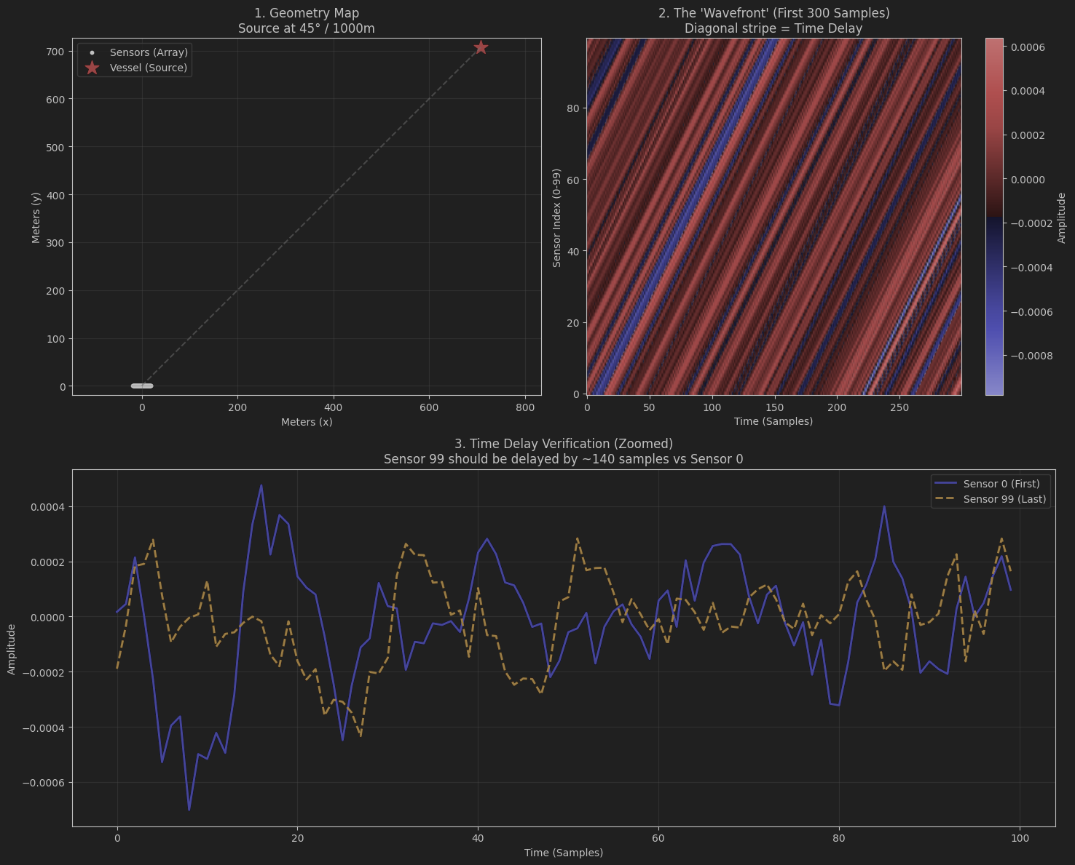
Step 4: Beamforming (The Transformation)
This is the function that converts your Sensor Data (100 rows, representing microphones) into the Theta Matrix (~200 rows, representing angles).
How it works (Delay-and-Sum):
- We define a grid of angles to scan (e.g., -90° to +90°).
- For each angle, we calculate the specific delays required to "steer" the array in that direction.
- We apply these delays (using phase shifts in the frequency domain for precision) and sum the signals from all sensors.
  - If the ship is there: The signals align perfectly, and the sum is loud (Constructive Interference).
  - If the ship is not there: The signals are misaligned and cancel out (Destructive Interference).
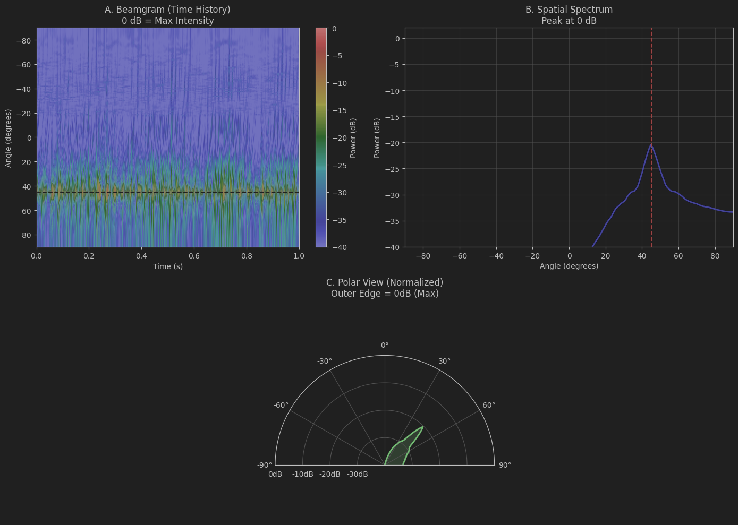
Step 5: The Two-Vessel Scenario
We have now reached the final step. Here, we simulate a realistic scenario with two different vessels present in the water at the same time.
What we are doing in this step:
- Independent Simulation: We load audio for Vessel A and Vessel B. We simulate the physics (delays and attenuation) for each vessel separately.
  - Vessel A is placed at Angle $θ_{1}$ and Distance $r_{1}$.
  - Vessel B is placed at Angle $θ_{2}$ and Distance $r_{2}$.
- Mixing: We combine the signals at the sensors. In the ocean, sound waves superimpose linearly, so we simply add the sensor data matrices:
$$Total Signal = SensorData_{A} + SensorData_{B}$$
- Global Noise Injection: We calculate the power of this combined mixture and add noise to achieve the desired SNR (e.g., 10dB). This represents the ambient ocean noise and sensor noise interacting with the total soundscape.
- Beamforming: We run the "blind" beamforming algorithm on this noisy mixture. It doesn't "know" there are two ships; it simply looks for energy in every direction.
